Unit Test cases (User Management)

1. Home Page. Click on the “New Person Register” to add a new person.

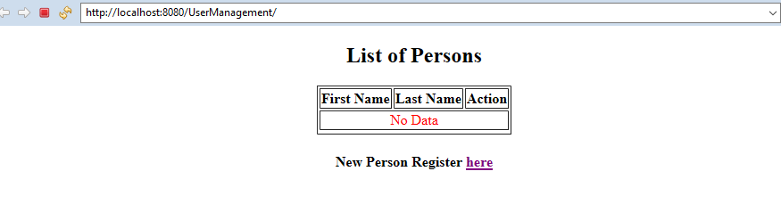

1. Home Page. Click on the “New Person Register” to add a new person. Validation message, if user submit the form without first name & last name.

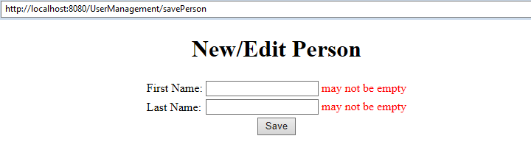

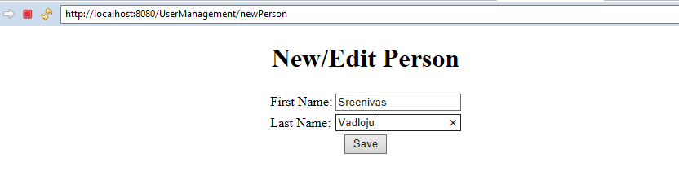

1. After adding the new person, it redirects to the home page. Now it shows the added user.

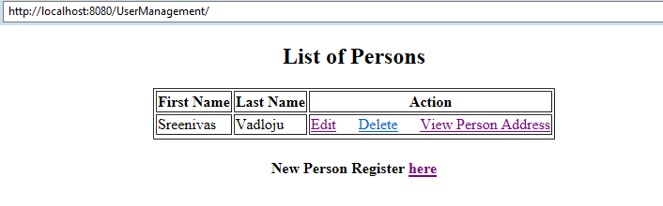

1. Click on the “View Person Address” to view the person details withy Address.

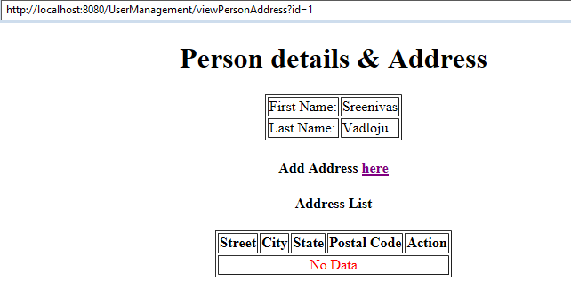

1. Click on the “Add Address” to add a new address to a person. We can add multiple address to a person.

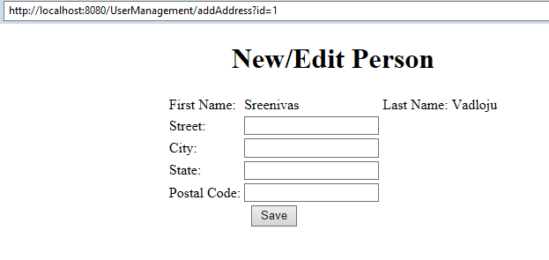

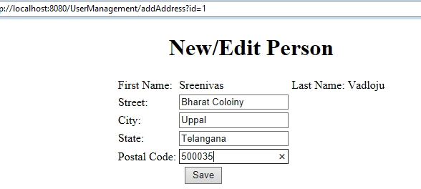

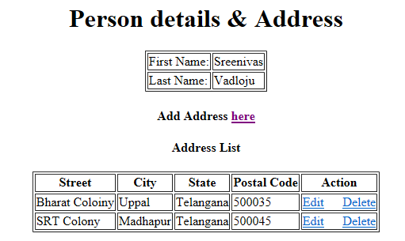

1. Click on the Edit link to Edit the address.

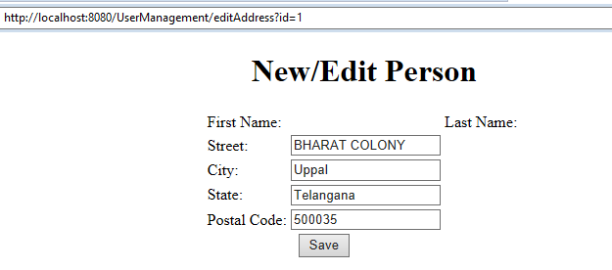

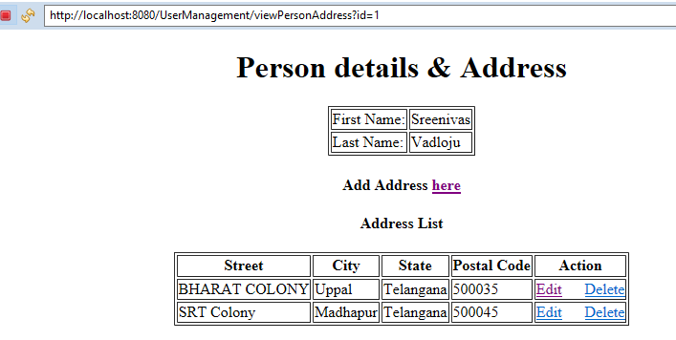

1. Click on the Delete Button to delete the address.

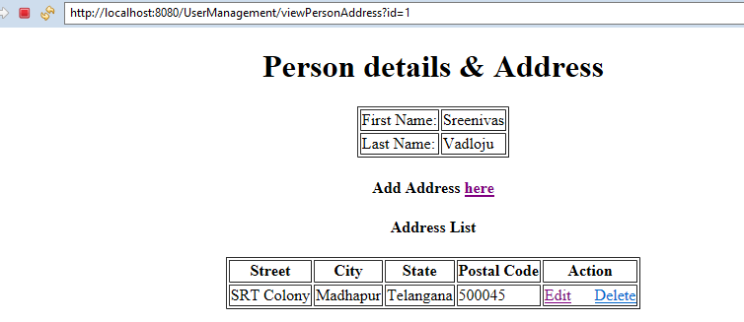

1. Click on the Edit link to edit the Person details. Here change the Surname to Caps.

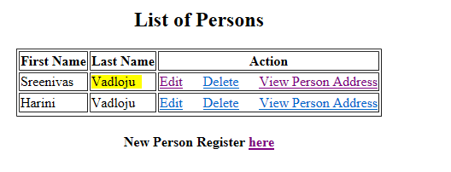

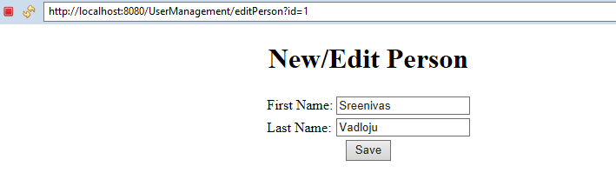

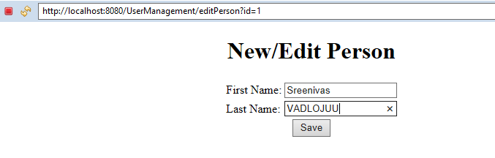

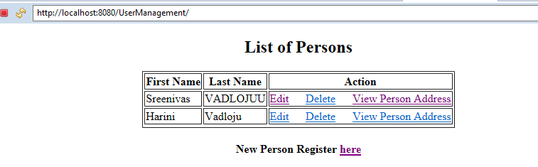

1. Click on the Delete link to delete the Person and Address.

